Pokhara University

Level: Bachelor | Semester – Spring | Year : 2005
Programme: BE |  | Full Marks: 100
Course: Basic Electrical Engineering |  | Time : 3hrs.

Candidates are required to give their answers in their own words as far as practicable.
The figures in the margin indicate full marks.

Attempt all the questions.

 | - Write the nodal voltage equations for the given circuit and find the current passing through 5Ώ resistor.  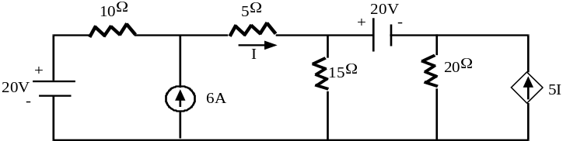  - State and prove the maximum power transfer theorem and also show that maximum power transferred to the load is P_{L}max = 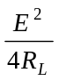; where symbols have their usual meanings. | 8  7
 | - Determine the current passing through 15Ω resistor connected across a-b terminal in the circuit using Norton's theorem.  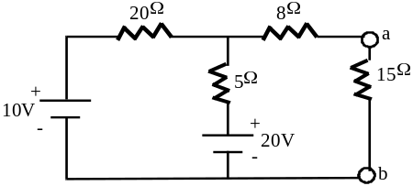  - Use Superposition theorem to determine the current through the 4Ω resistor in figure shown below.  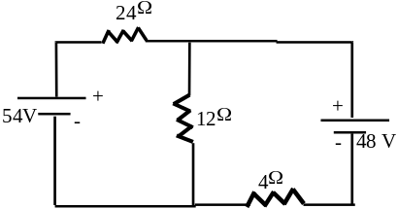 | 8  7
 | - Find the average and root mean square (rms) value of the following wave form.  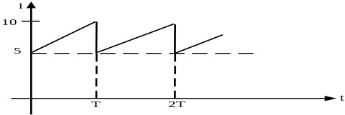  - Two impedance of (5+j10) Ω and (10-j5) Ω are connected in series across a 200 V, 50 Hz supply. Find current, active power, apparent power and reactive power and power factor. Also draw a phasor diagram. | 7  8
 | - Show that bandwidth of series RLC resonance a.c. circuit is w_{r} = 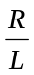rad/sec, where symbols have their usual meanings.  - A 50 Ω resistor, 5 mH inductor and 15 μF capacitor are connected in series across a 1 V source. Find resonant frequency, quality factor, bandwidth, current and voltage across capacitor at resonance. | 7  8
 | - A 20 KVA, 200/200 V, 50 Hz single phase transformer has the following test results.  Calculate the parameter of equivalent circuit of a transformer  referred to H.V. side.  - Derive the torque equation of DC machine. | 8  7
   | Volt | Ampere | Watt
  Open circuit test with H.V. open | 200 | 4 | 120
  Short circuit test with L.V. shorted | 60 | 10 | 300
 | - Draw and explain the no-load and load characteristics of DC series and shunt generator.  - A series motor takes a line current of 25 A and develops a torque of 100 Nm. Calculate the torque when line current is 30A. Assuming that the magnetic circuit is unsaturated. | 8  7
 | Write short notes on (Any Two):  - Single – phase energy meter.  - Hysteresis and eddy current loss  - Power factor and its significance | 2x5

